**Monetary Policy:**

* Engineer: the central bank (RBA)
* Lever: nominal interest rates
* Objectives: stabilize inflation (neutralize sticky prices)
* Considerations: Asset price bubbles
* Channel: Aggregate private demand (C, I, NX)
* Reaction speed: fast

Home loan:

* When a bank makes a new home loan, it just adds electronic numbers to the borrower’s account. This increases total deposits.

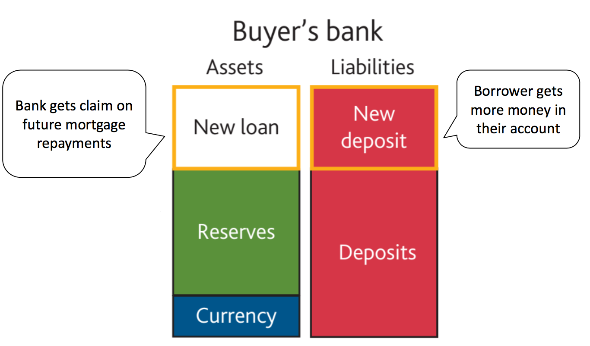

* The borrower will then withdraw the electronic numbers as cash (reserves) and give it to the house seller, who deposits with their bank

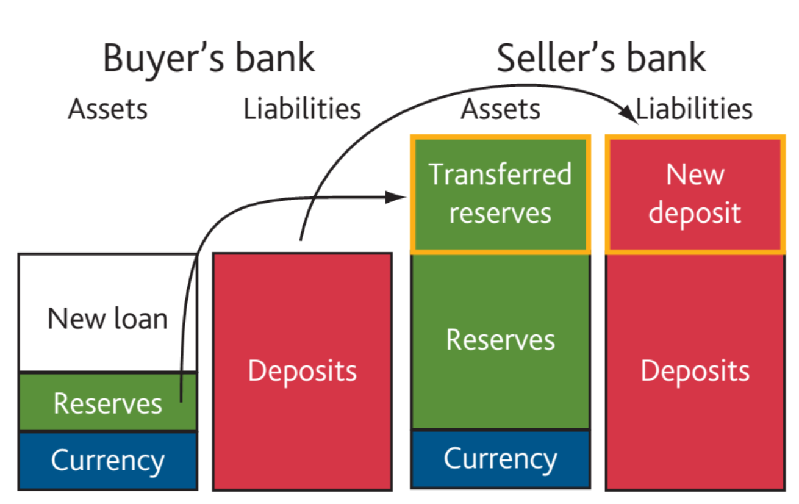

* Bank need to make profit, which is determined by interest on reserves

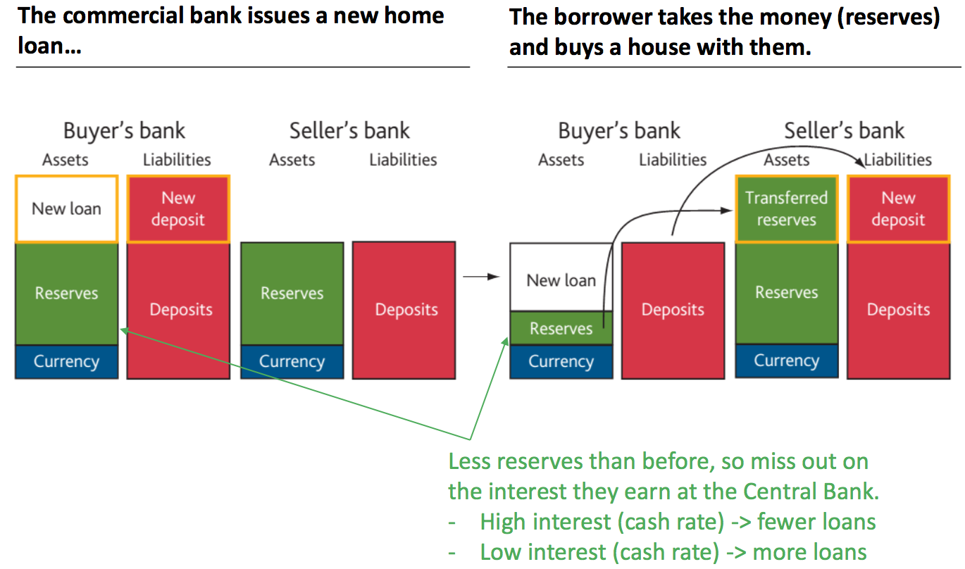

* When all banks are lending more, they will each also receive more deposits. Bank credit is self-reinforcing, leading to credit booms.

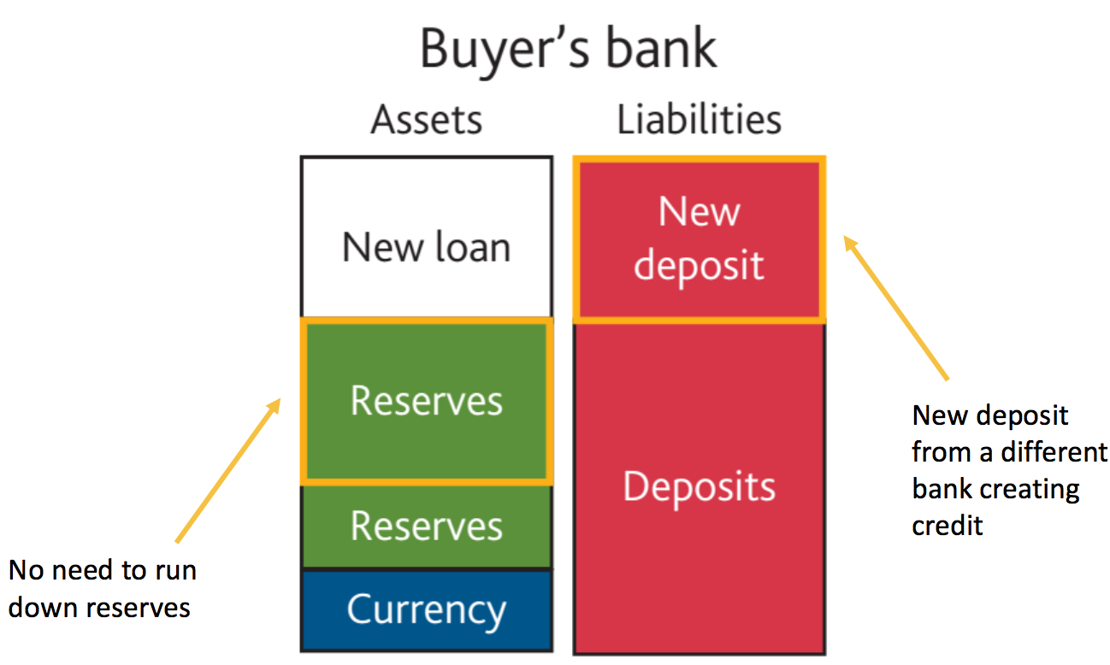

**How does the Central bank influence the money supply?**

* By setting the cash rate, which is the interest paid on reserves

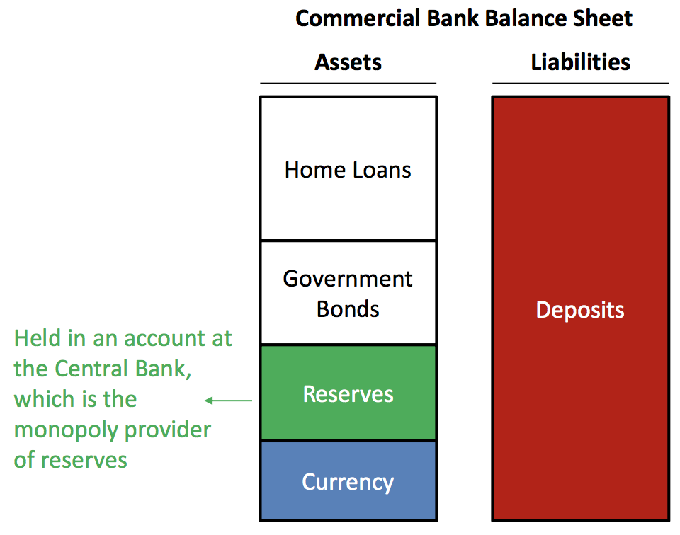

* The central bank sets the cash rate by announcing what it will be, and then buying/selling government bonds from banks to make it happen

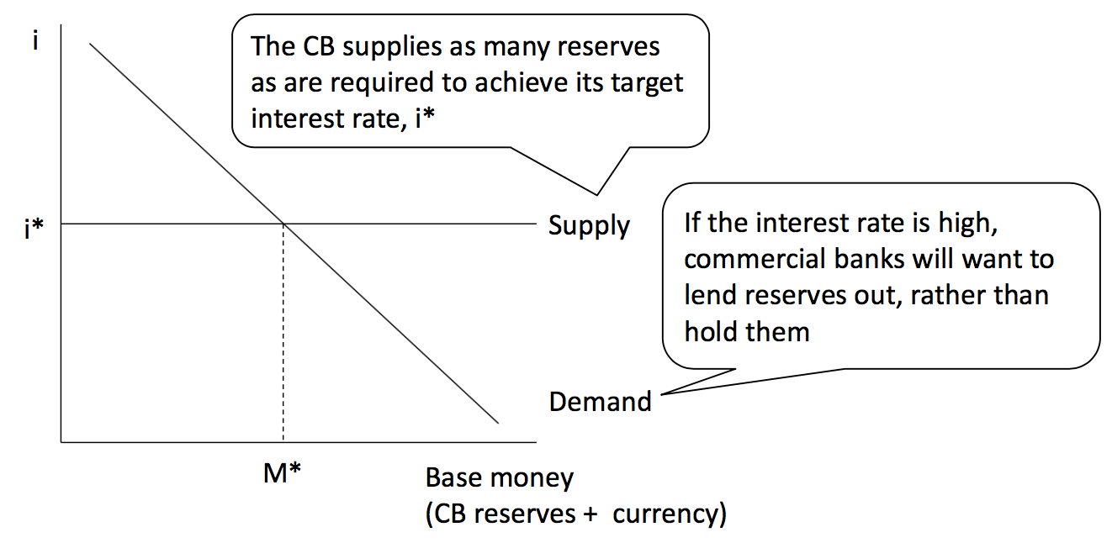

(RBA will either create or destroy reserves)

* **Bond**
* Bond is a loan to the government (a gov IOU), which can be bought and sold like other financial asset (eg. stocks)

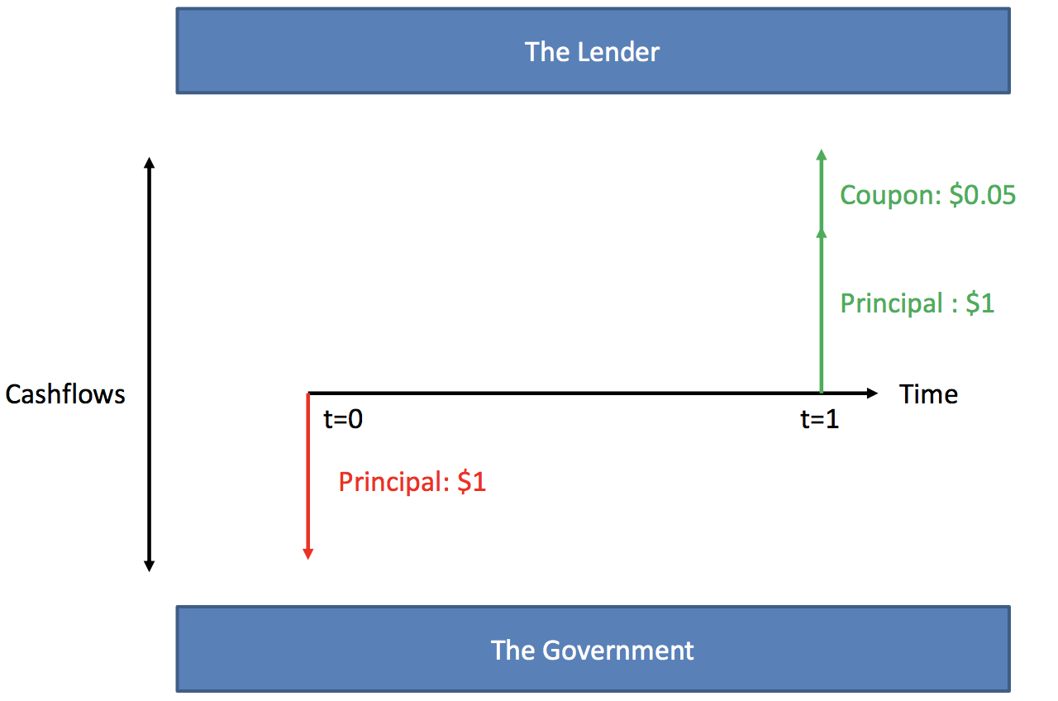

* The price of a bond (how much the lender could sell it for) depends on the discounted value of future income (principal + coupons): arbitrage

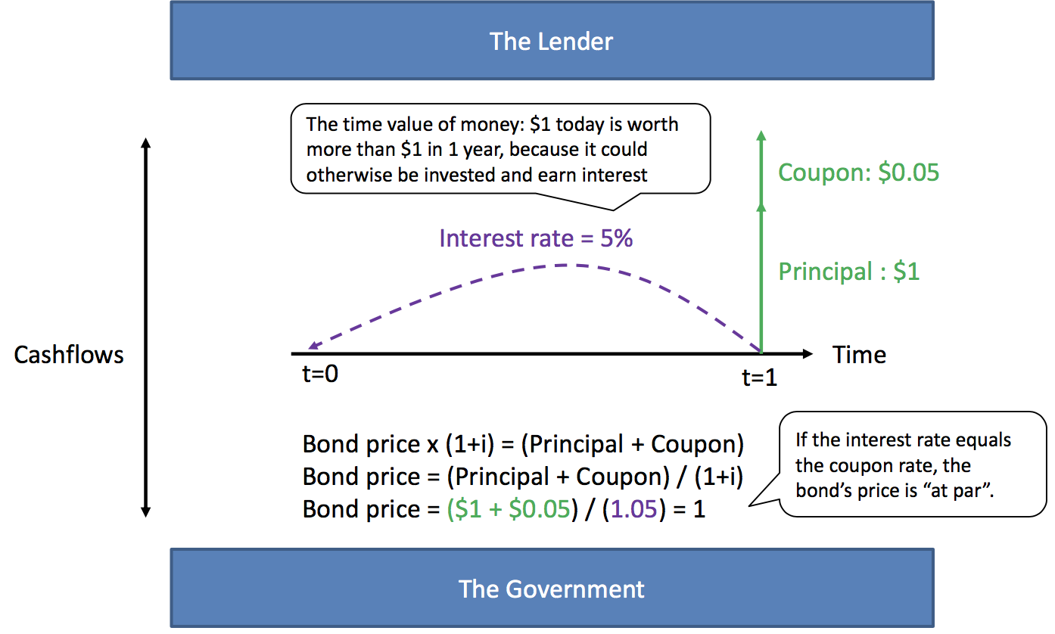

* A bond’s price will vary inversely with the interest rate

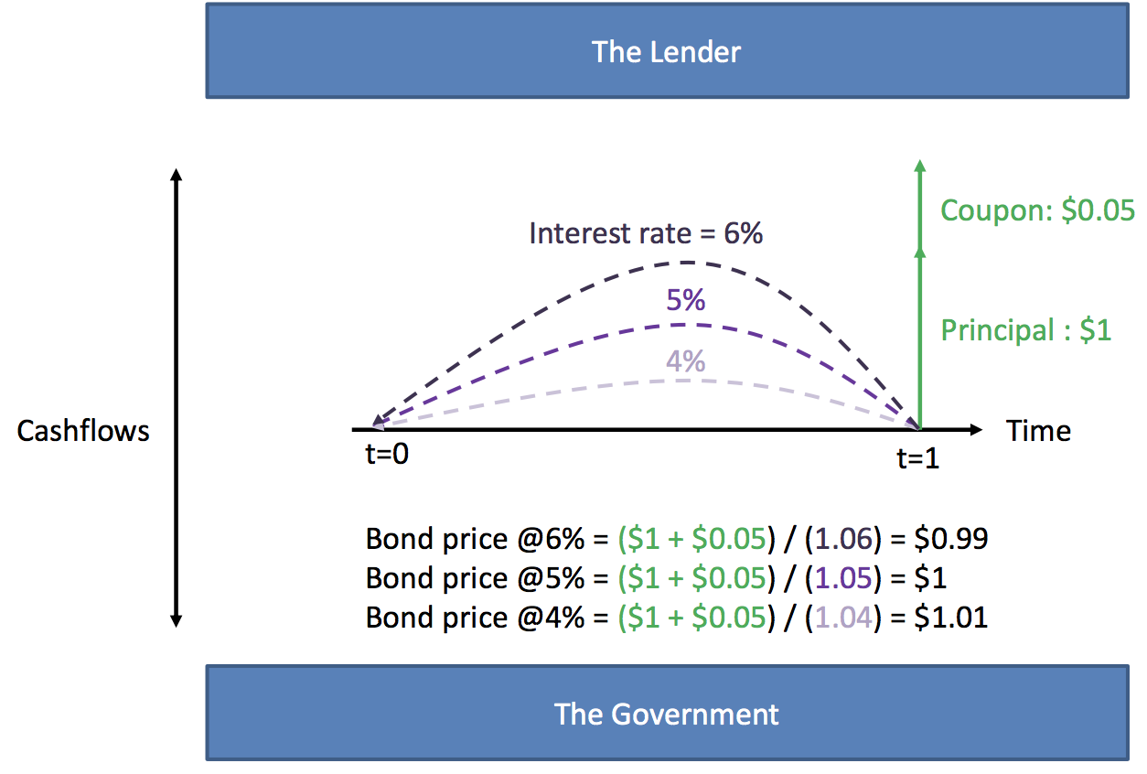

* Bonds can have different maturities. Their discount rate (yields) will differ based on expectations of cash rate changes & risk until maturity.

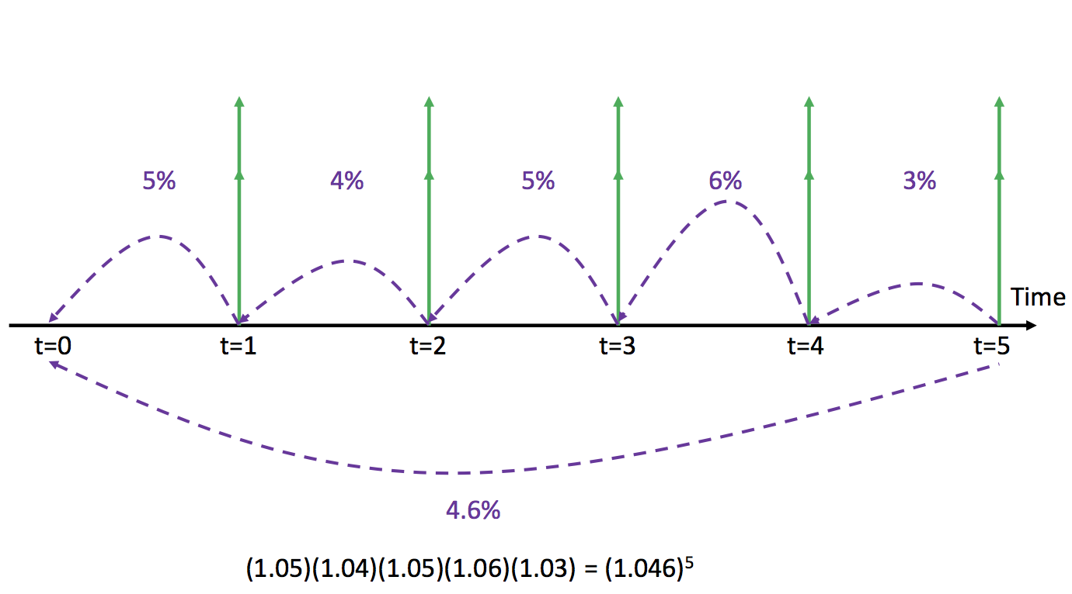

**Conventional monetary policy (Interest rates)**

* If the Central Bank decides to lower interest rates, then Commercial Banks will want to sell bonds and buy more reserves. (As the central bank want to speed the economy up by increasing the money supply)

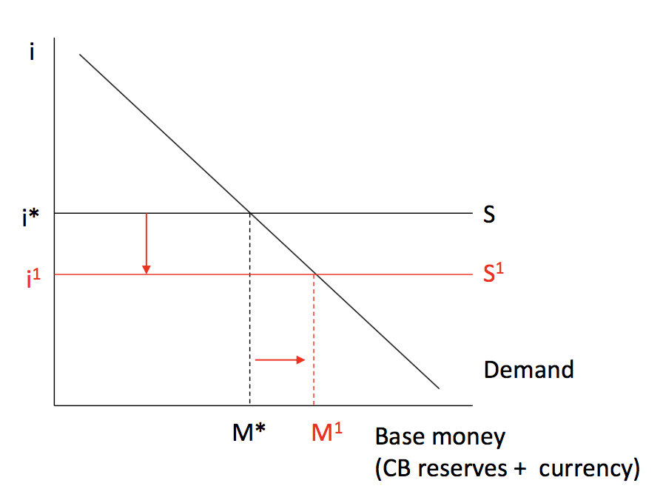

* To get more reserves the Commercial Banks will sell some government bonds to the Central Bank, in exchange for reserves.

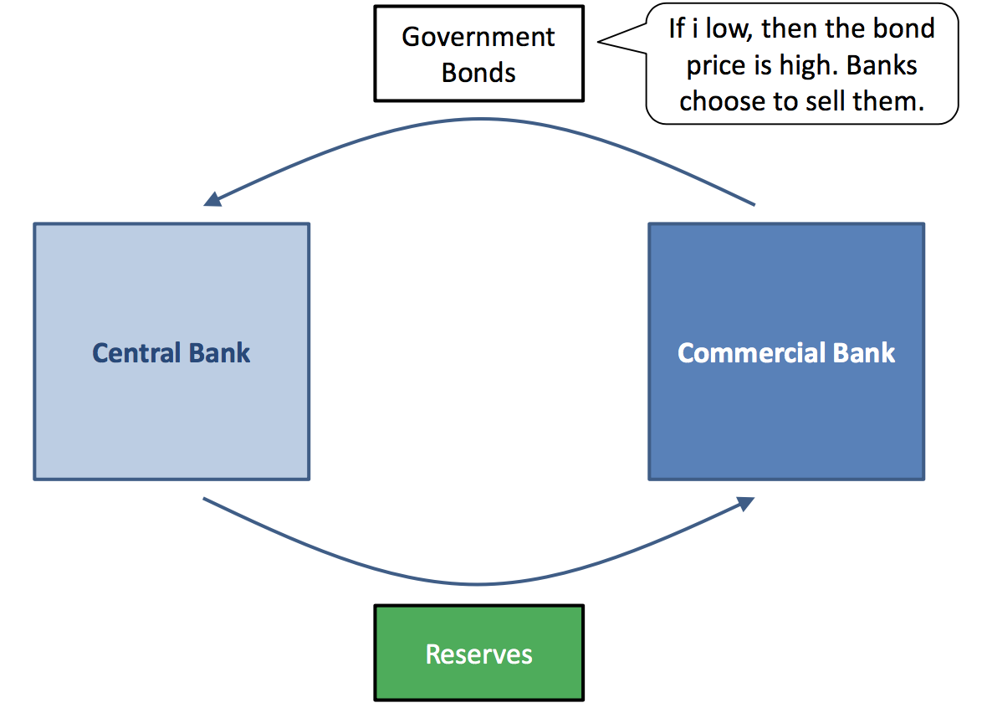

After the interest rate cut banks will have more reserves, and make more loans as more projects will be profitable, increasing the money supply